CS 3305-01 Web Programming 2

Instructor: Professor Jim Casale

Name: Anonymos

Programming Assignment Unit 4

**Section 4: If, Else & Elseif**

I have completed section 4 ‘If, Else & Elseif’.

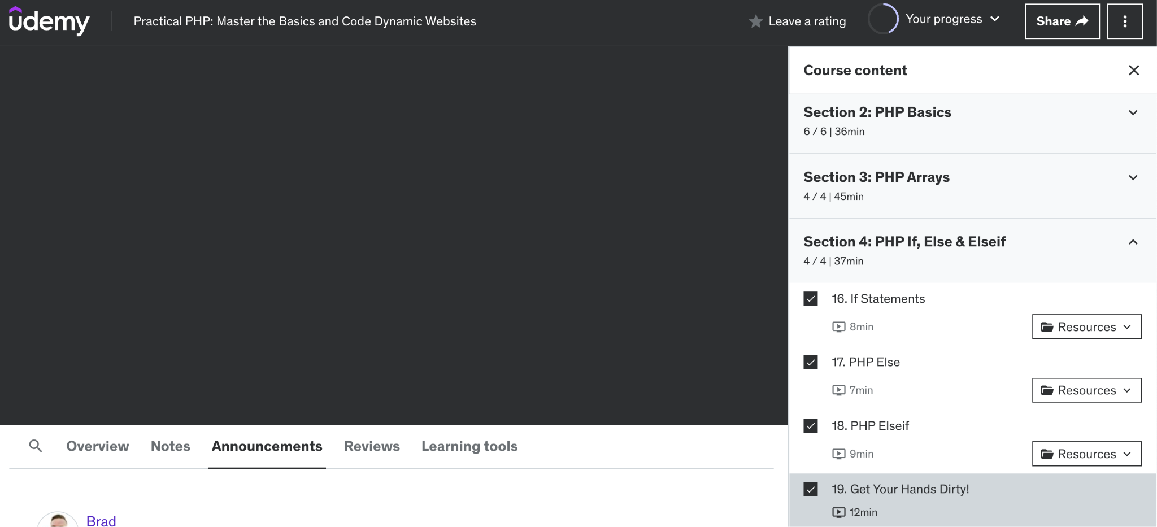

Figure 1-1. A screenshot showing that section 4 ‘If, Else & Elseif’ has been completed.

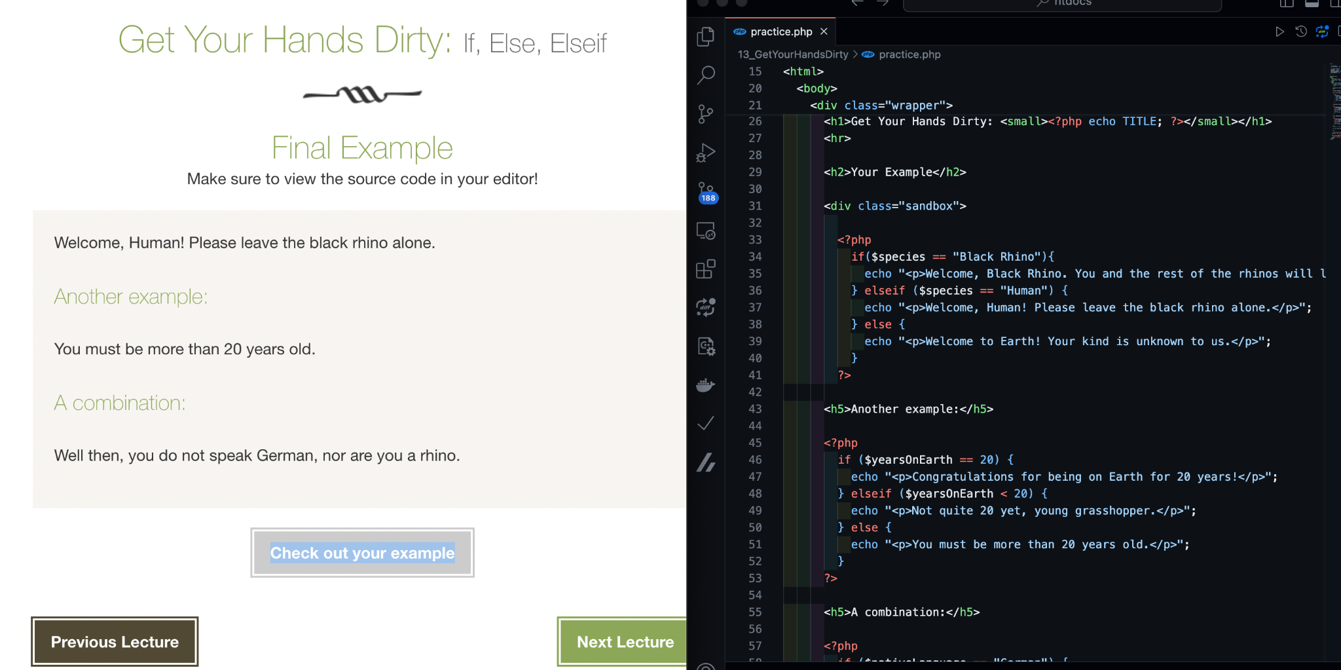

Figure 1-1. A screenshot showing that section 4 ‘If, Else & Elseif’ has been completed.

**Section 5: Operators**

I have completed section 5 ‘Operators’.

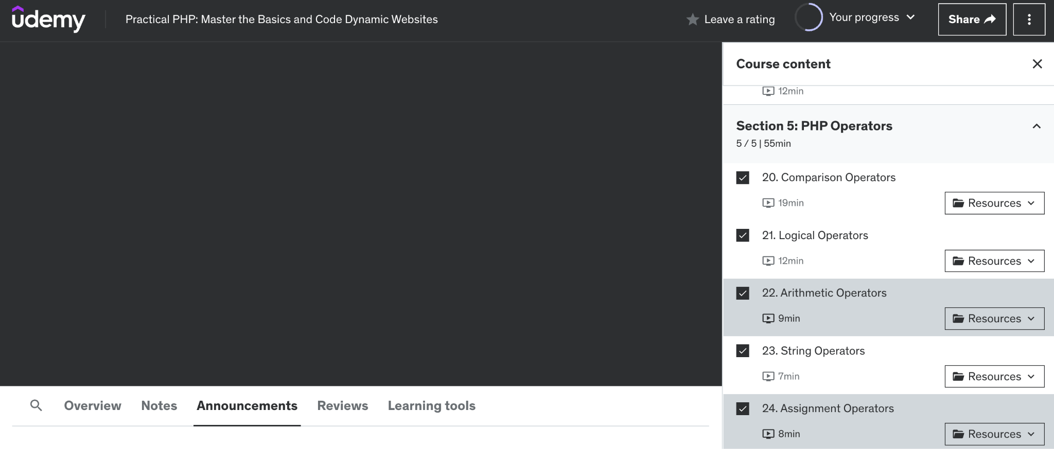

Figure 2. A screenshot showing that section 5 ‘Operators’ has been completed.

**Section 6: Loops**

I have completed section 6 ‘Loops’.

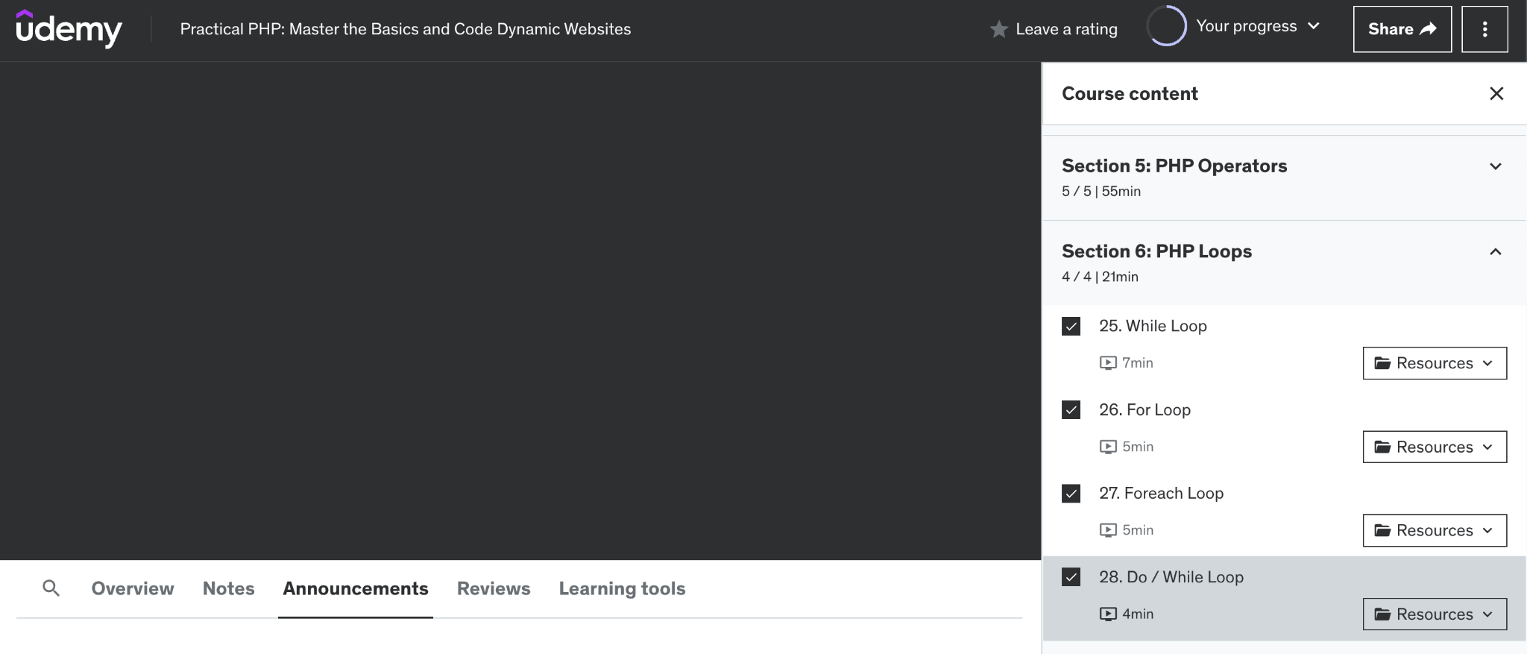

Figure 3. A screenshot showing that section 6 ‘Loops’ has been completed.

**Section 7: Functions**

I have completed section 7 ‘Functions’.

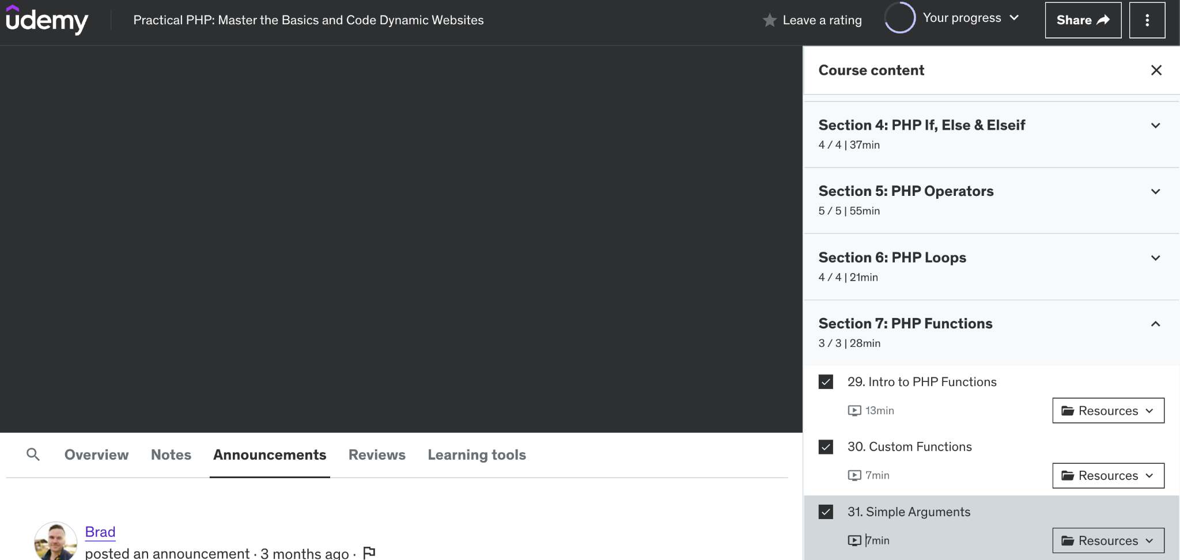

Figure 4. A screenshot showing that section 7 ‘Functions’ has been completed.

Word Count: 108

References

1. Brad Hussey, Code College. (n.d.). *Practical PHP: Master the Basics and Code Dynamic Websites.* Retrieved from https://www.udemy.com/course/code-dynamic-websites/